Job description

Job title: Head of Partnerships
Team: Fundraising & Marketing
Department: Fundraising
Job location: Andover or Home Based
Reports to: Director of income and transformation

Overall purpose
Macular disease is the biggest cause of sight loss in the UK, with around 300 people diagnosed every day. The Macular Society is the only charity determined to beat the fear and isolation of macular disease with world class research, and the best advice and support.

To support people affected by macular disease now, the Macular Society provides a range of support, information and services. Our research programme is focused on finding new treatments and a cure to Beat Macular Disease forever.

Role Overview
We’re looking for a driven and ambitious Head of Partnerships who can help us to secure the corporate partnerships that beat Macular Disease.

To do this, we’re looking for someone with a proven track record of securing partnerships or clients. This could be cause-related marketing, sponsorship or previous B2B sales.

Taking a sector-led approach, focussing initially on pharmaceutical and eye-themed industries, you’ll be in charge of developing and delivering high value and high impact partnerships. With a starting pipeline of warm prospects identified through our organisation’s existing contacts, you’ll be in charge of developing and delivering partnerships.

Perfect for someone stepping up from a Senior Partnerships Manager or equivalent role, you’ll act as the ‘Head’ and ‘Shoulders’ of our corporate team. You’ll be supported with strategic thinking by our Director of income & transformation and supported in the doing through our work with agency Fireside Fundraising.

This is a unique opportunity to make a meaningful impact—helping us beat a growing health problem across the UK.

Organisational chart

Organisational chart shows role reporting to the Director of income and transformation.

Our values
We will beat macular disease by…
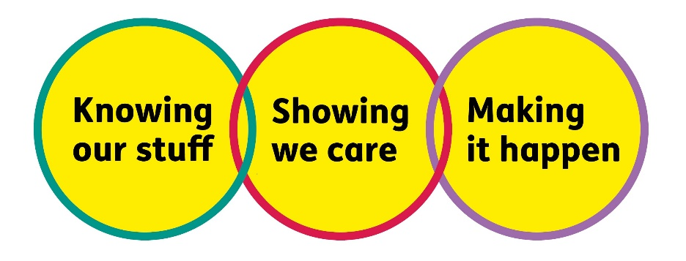
- Knowing Our Stuff - we have Integrity and we act Honestly

Showing We Care - we are Supportive and Caring

Making It Happen - we are Ambitious

About the role

● Hit our evidence-based income targets by working on a strong, qualified pipeline of corporate prospects.
● Create tailored plans, proposals, and presentations to inspire partners.
● Lead negotiations and contracts to secure mutually beneficial partnerships.
● Provide a solid, satisfying partnership experience that means companies keep coming back year after year.
● Identify new opportunities for growth with our existing partners - whether through referrals to their network or within the company itself.
● Adapt our existing corporate partnerships strategy as needed, ensuring we have accurate forecasts.
● Stay on top of trends across business and charity sectors.

All our team members are expected to comply with Macular Society terms and conditions, rules, policies, procedures, codes of conduct, quality standards, authorisation processes, risk management policies and relevant external regulations.

About you
1. You will be committed to equality, diversity and inclusion in all aspects of our work.
2. Have an open and collaborative approach to work, helping us to achieve our Knowing Our Stuff value by working with integrity, making informed decisions to be the best we can be to Beat Macular Disease.
3. Be able to act with empathy, providing a caring, approachable and supportive environment for all – we Show We Care by listening to each other and working together.
4. Be ambitious in your approach to help Make Things Happen, we are progressive yet supportive, and brave in our actions to make the progress that is needed to Beat Macular Disease.
5. Be happy to work in an organisation that puts those we support first, advocate for the Macular Society at all times, and be comfortable that all members of the team are part of our fundraising culture.

Specifically for this role you will have:
Knowing Our Stuff
- Background in a sales or fundraising environment and proven experience securing partnerships worth at least £50,000.
- Strong track record in building and maintaining both internal and external relationships that support organisational objectives.
- Successful track record of achieving financial targets.

Making It Happen
- Proven ability to build compelling, tailored partnership proposals and deliver persuasive presentations to senior and board-level decision-makers.
- Confidence in representing the organisation externally, influencing stakeholders, and communicating complex ideas with clarity and impact.
- Experienced in working collaboratively with internal and external teams to secure high value partnerships sharing insights and best practices across functions.
- Proven ability to actively listen to what an organisation needs, including reading between the lines, and flex what’s provided to them accordingly.
- Ability to work independently under own initiative and cooperatively as part of a team.
- Strong IT skills including Microsoft 365 and Dynamics.

Showing We Care
- Excellent team working and collaborative working skills and the ability to develop effective partnerships.
- Commitment to high standards in all areas of work.

Eligibility to work in the UK:
Proof of identity and eligibility to work in the UK.

Volunteering:
From time to time you may be asked to support / volunteer your time (TOIL available) at Macular Society events that take place outside of normal working hours.

Safeguarding:
The Macular Society is committed to safeguarding and promoting the welfare of all children, young people and vulnerable adults with whom we work. We expect all of our employees and volunteers to demonstrate this commitment.
You are required to carry out other such duties as may reasonably be required, relevant to the role.
This job description is accurate as at the date shown below. In consultation with you it is liable to variation by the Macular Society to reflect or anticipate changes in or to the role.

Annual leave: 26 days plus bank holidays (pro rata for part time)
Based: Andover/Hybrid/Remote
Contract Type: Permanent/Full Time

Date of evaluation: September 2025

