## About us

Every day, around 300 people are diagnosed with macular disease. It’s the biggest cause of sight loss in the UK. Macular disease is cruel and isolating. It steals your sight, your independence, and your ability to do the things you love.

The Macular Society is working to deliver our ultimate ambition – to Beat Macular Disease. We are determined to end the fear and isolation of macular disease with world-class research and the best advice and support.

## Our values

We will beat macular disease by…

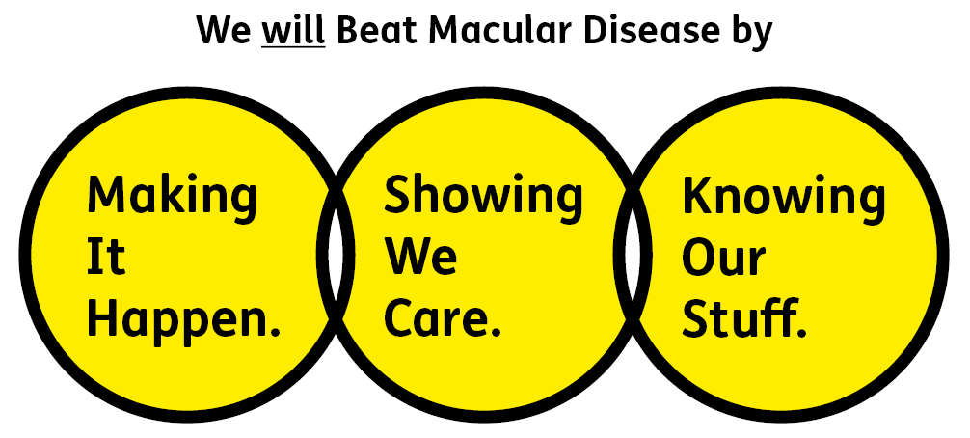

### Knowing Our Stuff - we have Integrity and we act Honestly

### Showing We Care - we are Supportive and Caring

### Making It Happen - we are Ambitious

We are passionate about treating people fairly and as equals, doing so is instinctive to us. We know that to Beat Macular Disease for all we have work to do. That’s why we are keen to hear from people of all backgrounds who have the skills and experience we are looking for. We particularly encourage applications from people from under-represented groups, to help ensure what we do and how we do it is inclusive – for everyone.

**Role Description**

**Title:** Trustee of the Macular Society

**Reporting to:** The Chair of the Board of Trustees

**Term:** Initially 3 years with an option to extend to a maximum of 6 years.

**Remuneration:** This is a voluntary role. Travel and other reasonable expenses will be reimbursed.

**Time Commitment:** Up to 3hrs per month in addition to attendance at Board meetings (currently 4 meetings each year including our annual strategy day). Trustees are asked to become a member of at least one sub-committee or task and finish group. These currently meet 4 times a year.

## Travel Commitment: Board meetings take place in Andover, Hampshire or Central London. Trustees can join Board meetings remotely but in-person attendance is encouraged. Sub-committees are normally held online.

## About the Trustee role:

As part of our Board of Trustees, your role will be to contribute to the overall governance and strategic direction of the charity, using your knowledge, skills and experience to ensure the Macular Society achieves its charitable objectives. Alongside the key statutory duties of a charity trustee, the role of trustee requires effective leadership in the following areas:

* Maintain our vision, mission, and values in collaboration with the senior leadership team.
* Be a proactive ambassador and advocate for the Society always acting in its best interests.
* Support the CEO and senior leadership team as a new strategic plan is developed.
* Bring any specific knowledge or experience you may have to help the Board of Trustees reach sound decisions.

**We ask the following for all our team members:**

1. You will be committed to equality, diversity and inclusion in all aspects of our work.

2. Have an open and collaborative approach to work, helping us to achieve our Knowing Our Stuff value by working with integrity, making informed decisions to be the best we can be to Beat Macular Disease.

3. Be able to act with empathy; we provide a caring, approachable and supportive environment for all – we Show We Care by listening to each other and working together.

4. Be ambitious in your approach to help Make Things Happen; we are progressive yet supportive, and brave in our actions to make the progress that is needed to Beat Macular Disease.

5. Be happy to work in an organisation that puts the people we support first, be able to advocate for the Macular Society at all times and be comfortable that all members of the team are ‘fundraisers’.

**Responsibilities of Trustees:**

**Knowing Our Stuff**

* Comply with statutory duties of a Trustee under the Charities Act, and those of a Director under Company law.
* Use own specific skills, knowledge or experience to help the Board reach sound decisions through the scrutiny of Board papers and contribution to Board discussions.
* Work with colleagues to develop knowledge and capabilities of the Board and senior leadership team.

**Showing We Care**

* Demonstrate a genuine interest in the vision and purpose of the charity, with a commitment to people living with macular disease.
* Listen to the voices of our beneficiaries, volunteers, staff and other stakeholders of the Macular Society.
* Fully engage with the decisions of the Board and ensure all decisions are implemented.
* A commitment to the ethical principles that are associated with the role of a trustee. These principles are selflessness, integrity, objectivity, accountability, openness, honesty and leadership.

**Making It Happen**

* Apply strategic vision to governance and decision making.
* Work effectively as a member of the Board while simultaneously sharing independent views that can constructively challenge the status quo.
* Ensure that the governance arrangements are working in the most effective way to achieve the charity’s objectives and strategic goals.
* Work collaboratively across the organisation and develop effective internal and external partnerships.

## Person Specification

We wish to encourage applicants from a wide variety of backgrounds who will bring a breadth of expertise and experience to the Board. We also wish to encourage applicants from all four countries of the United Kingdom.

Essential

* A commitment to our mission to beat macular disease.
* Senior leadership or clinical experience within the health or charity sectors
* A willingness to review board papers and contribute to discussions at meetings.
* A willingness to support the operational management of the charity through collaboration with the staff team.
* A commitment to comply with all Macular Society policies and procedures, together with the codes of conduct for Trustees.
* A commitment to support the Macular Society in high standards of data security and risk management. All Trustees are provided with an email address for Society work.
* A willingness to sit on appraisal, recruitment, and other panels or working groups that may be appropriate from time to time.

Desirable

* experience of risk management, governance, and legal matters within the health or charity sector.
* experience in human resources or employment law.
* experience of safeguarding policies and procedures in relation to vulnerable adults.
* lived experience of macular disease.
* experience working as an eye care professional in the area of macular disease, low vision management and service provision.